**1. Image description**

This image has installed the sound card driver and the virtual environment, the wake-up word is **hey yahboom!**

If you feel that the wake-up effect is not good or you cannot wake up, you can use WinSCP to transfer the recorded new wake-up file to the Raspberry Pi system to change the wake-up word.

In our multiple tests, we found that “hello” better as a wake-up word for most customers. (high success rate, but easily interrupted by self-excitation, it is recommended to use headphones) **So we need to replace the wake file in the image with the hello wake file.**

About how to generate a new voice wake-up file, and how to replace the voice wake-up file in the image, please read the tutorial we provide carefully

**[How to record wake-up word by Snowboy]**

**[How to remote transfer voice file]**

**2.About reference program**

2.1 Light up a RGB light

Input following command, as shown below.

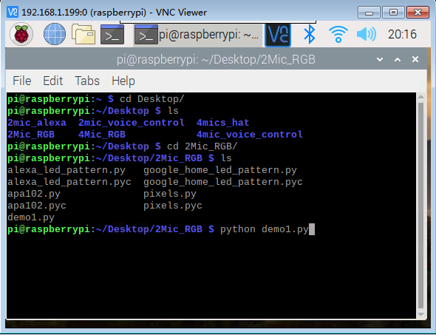

**2.2 Run the voice wake-up program**

2.2.1 Enter the virtual environment and authorize

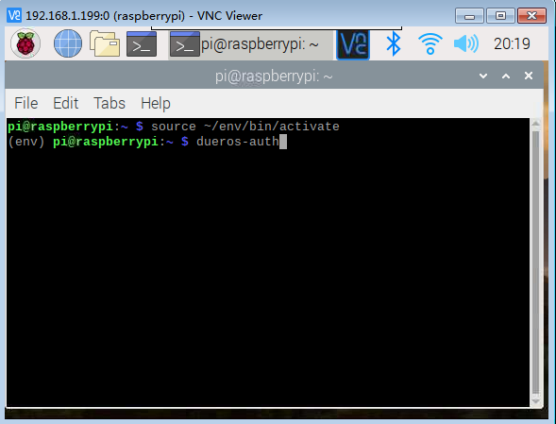

2.2.2 The screen shown below indicates that our authorization is successful.

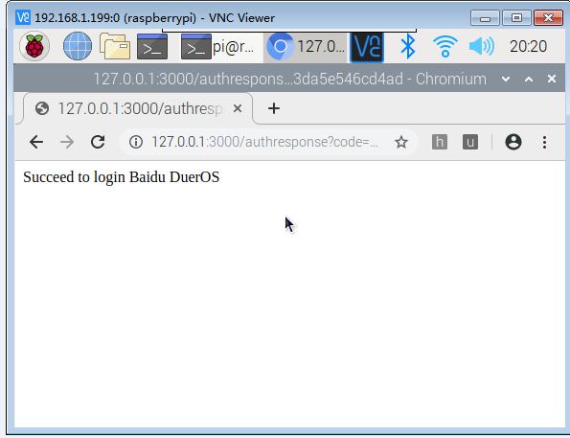

2.2.3 Run the voice wake up command

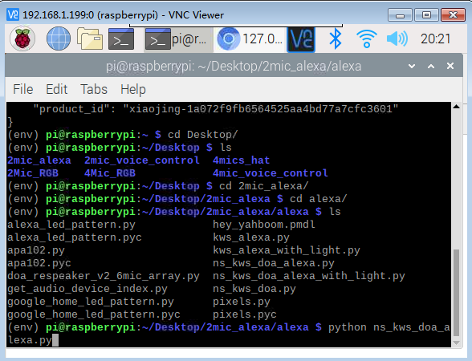

2.3 Voice control lights on and off

Input following command, as shown below.

